

Name : Karthikeyan V

Expt.no : 1

Date : 24-12-2022

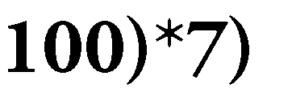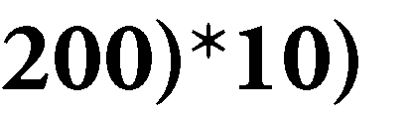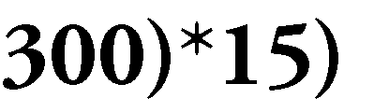

Step 1: Declare the variables like item1, item2, item3, a1, a2, a3, and amount.

Step 2: Assign the values for a1, a2 and a3; a1=15, a2=120, a3=85. Step 3: Read the values of item1, item2, and item3.

Step 4: Process the following

amount=(item1*a1) + (item2*a2) + (item3*a3)

Step 5: Display the value of “amount”.

**Step 5: Stop.**

1. Sin Series

The formula for the 'sin x' is represented as

sin x= x-x3/3!+x’/5!-x’/7!+x’/9!- .................. (where x is in radians) Step 0: Start.

Step 1: Declare the variables which are required to process.

Step 2: Read the input like the value of x in radians and n where n is a number up to which we want to print the sum of series.

Step 3: For first term,

**sum=x;**

p=1 (variable p is used for denominator) num=x (variable num is used for numerator) power= 1

Step 4: For next term,

num=num* (-x2); power=power+2; p=p*(power-1)*power next=num/p;

Step 5: then sum=sum+next.

Step 6: Repeat the step 4 and step 5› looping 'n-1' times to get the sum of first 'n' terms of the series.

Step 7: Display the value of sum. Step 8: **Stop.**

1. Weight of a Motorbike
   * Motorcycle maximum load is the total weight the bike can carry including the rider, passenger and

any cargo.

* + Gross Vehicle Weight (GVW) of your motorcycle is the weight of the motorcycle itself plus all

engine fluids and full fuel, plus the maximum allowable weight of the rider and passenger.

* + Motorcycle curb weight, or wet weight, is the weight of the motorcycle itself plus all engine oils

# and full fuel.

Step 0: Start

Step 1: Declare variables weightmotor, pr, eoff and weight. Step 2: Read the values of weightmotot, pr, and eoff.

Step 3: Process the following

weight=weightmotor+pr+eoff.

Step 4: Display “Motorbike Weight Result is weight”.

## Step 5: Stop.

1. Weight of a steel bar

Weight of steel bar = (d2 /162)*length (Where d value in mm and length value in m)

Step 0: Start.

Step 1: Declare the variables d, length and weight.

Step 2: Read the value of d and length.

Step 3: Process the following weight=(d 2 /162)*length

Step 4: Display the value of weight.

## Step 5: Stop.

1. Compute Electrical Current in Three Phase AC Circuit

Perform a three phase power calculation using the following formula:

## P=13 X pfX I X V

Where pf - power factor, I - current, V - voltage and P — power

Step 0: Start

Step 1: Declare variables pf, I, V and P. Step 2: Read the values of pf, I and V. Step 3: Process the following:

## P=13 X pfX I X V

Step 4: Display “The result is P”.

## Step 5: Stop

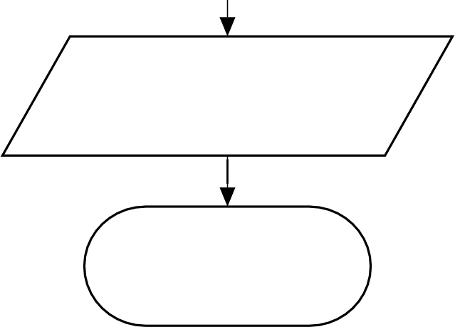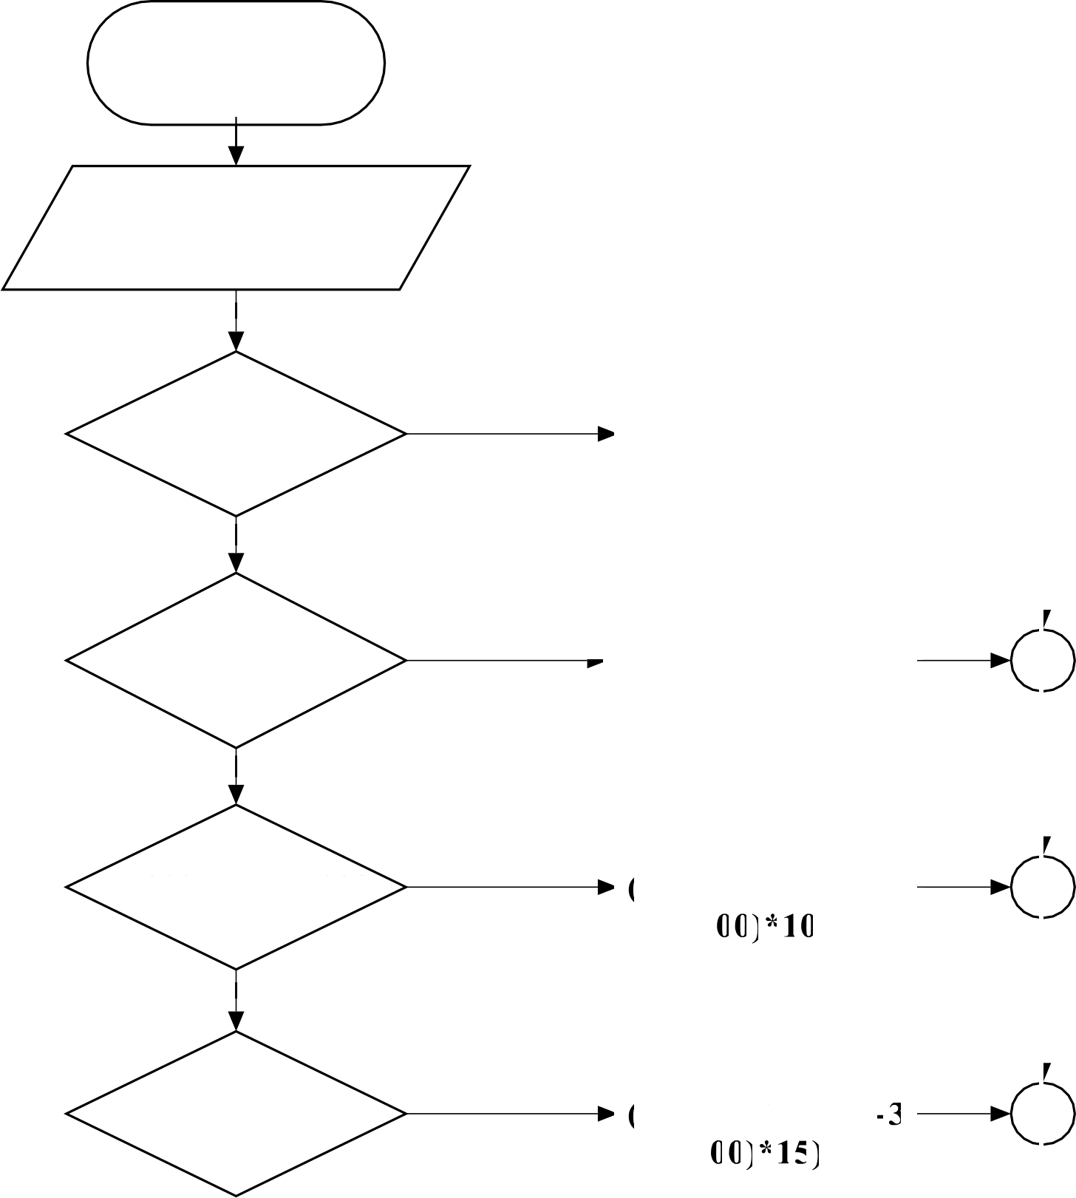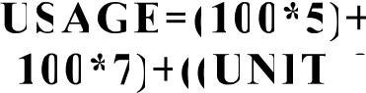

START

READ UNI'I

IF UNIT<=100

TRUE

FALSE

IF 100<UNIT<200

TRUE

FALSE

IF 200<UNIT<300

TRUE

FALSE

IF UNIT>300

TRUE

DISPLAY ”USAGE”

STOP

USAGE=(100*5) ((UNIT-100)*7)

USAGE=UNIT*5

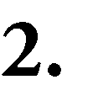 

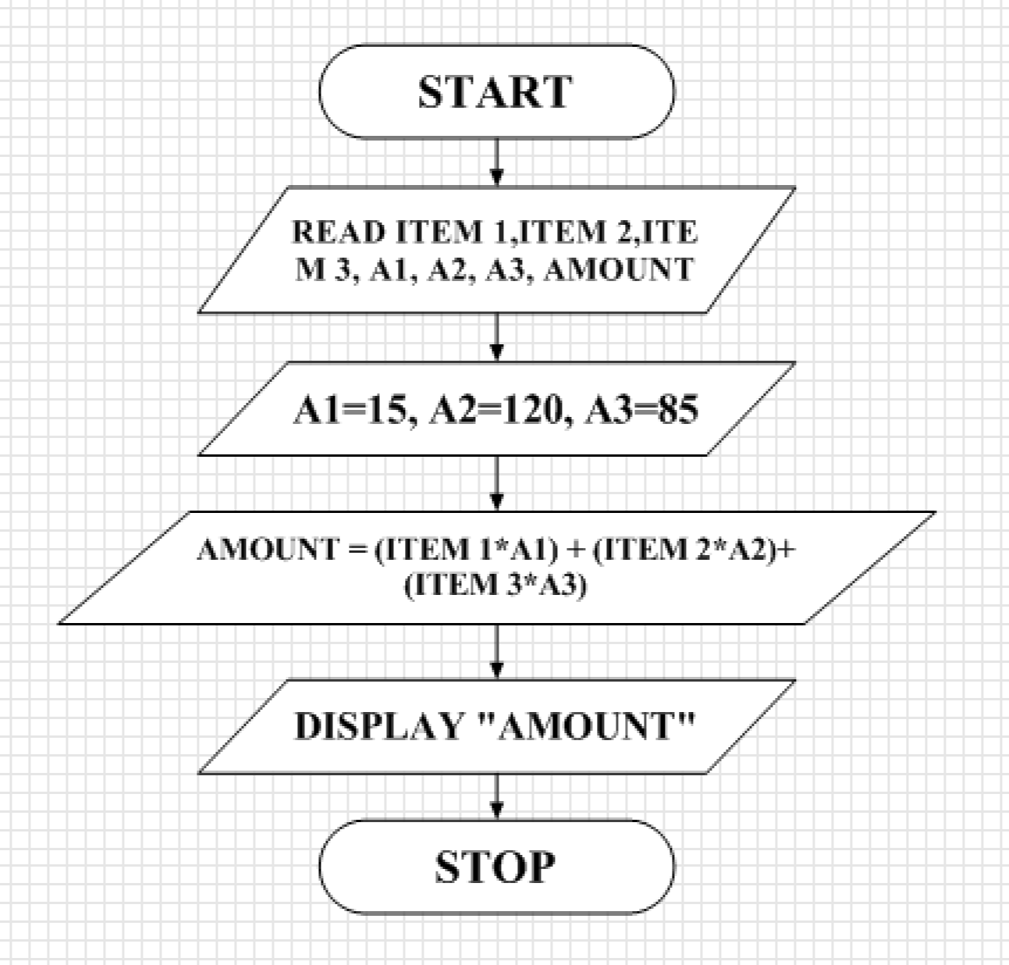

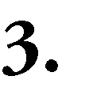 

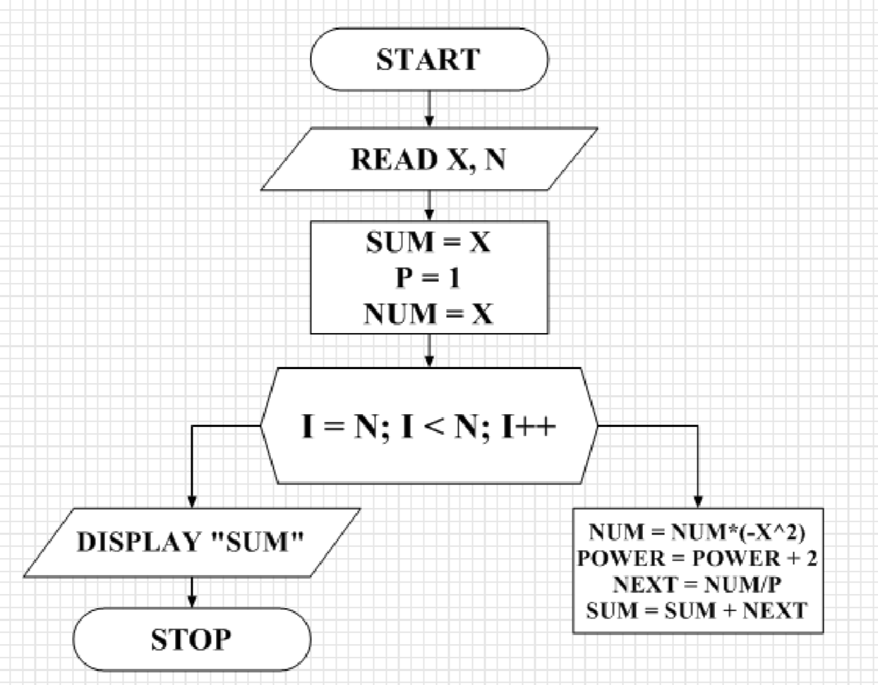

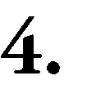 

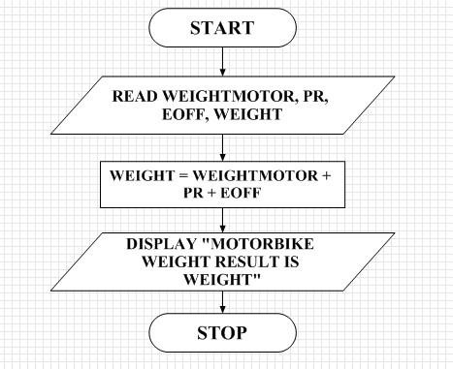

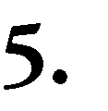 

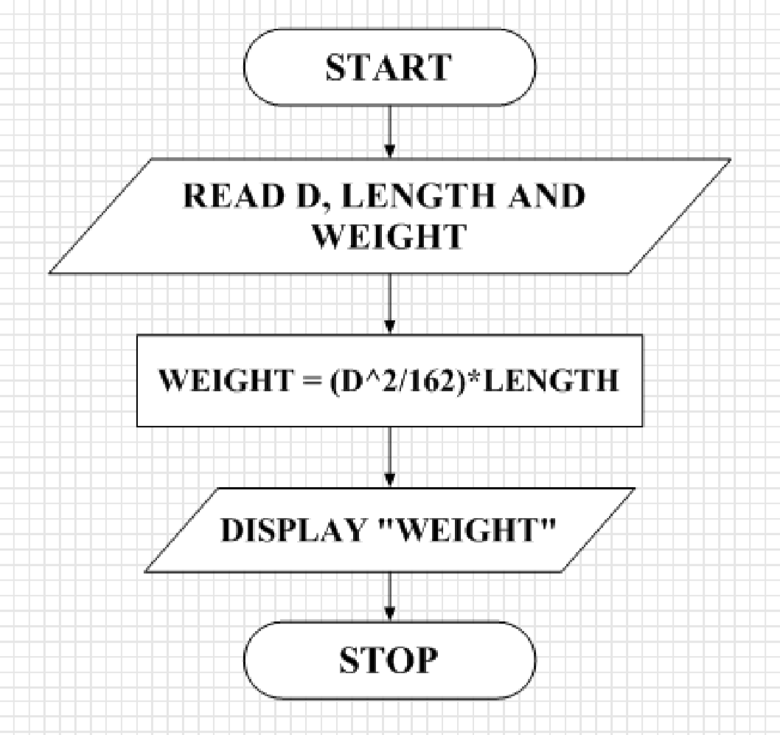



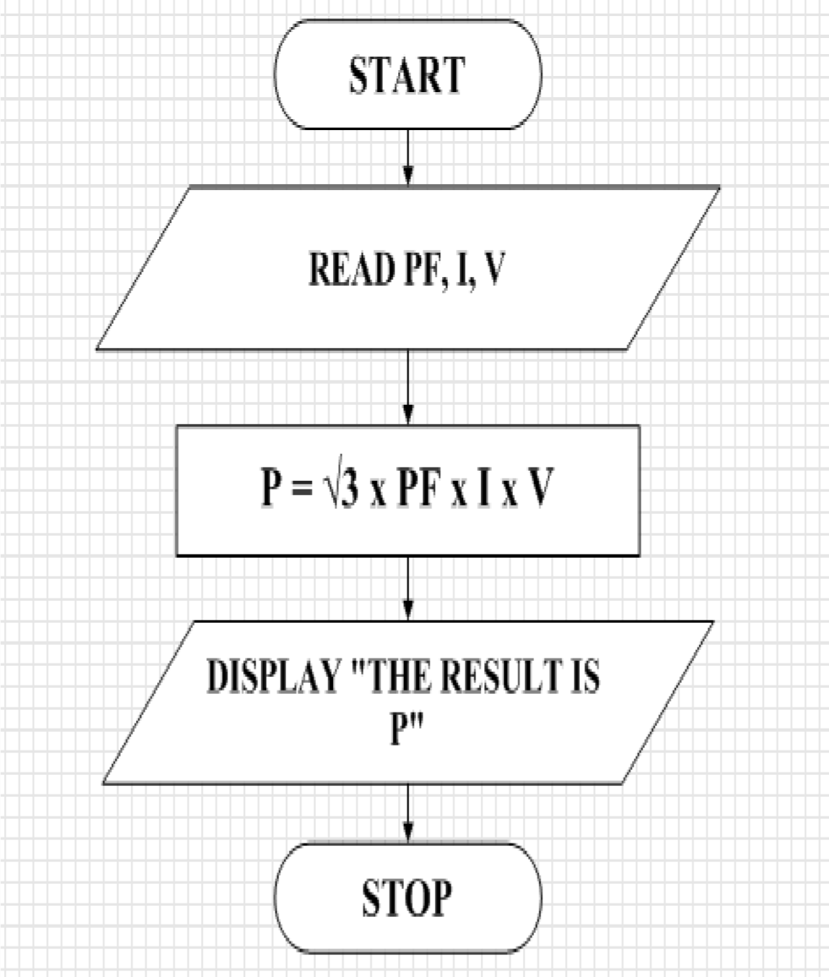

M.Samhita

